A Systemic Review of Trends in Cranial Capacity of urban-rural mammals: Domestication Syndrome or Cognitive Demand
((urban-rural comparison OR urbanisation gradient OR urbanization gradient) AND (mammal OR mammalian OR primate OR monkey OR feline OR felinae OR felidae OR canine OR racoon OR coyote OR fox OR rat) AND (cranial morphology OR braincase OR brain volume OR cranial volume OR cranial capacity))
Returned 366
Screened until first full page none worthwhile (n=50) – 37 thrown out (irrelevance, taxa)
13 went through
3 extracted effect sizes for a total of 18 effect sizes
Moderator – why some go up some go down
- Hypotheses
Species/paper as random effect

Lxwxh then LM with body size as predictor & urban-rural as factor
Model<-lm(volume~bodysize+urbanrural-1)

https://github.com/estermayk/meta_analysis

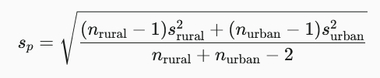 pooled sdev



COVER SHEET

Name of Course
EcoEvolutionary Responses to Anthropogenic Change

Title of Assessment
Meta Analysis

Student Exam Number: | B289401

The file name of your uploaded document must include your exam number.

Declaration
I have/have not used Generative AI-based methods (e.g. ChatGPT) in the preparation of this assessment other than allowed by the instructions that were specific to this assessment.  Note: School policy forbids its use unless permission is granted by your Course Organiser. | I have not
If Generative AI-based methods were used; please provide details of the software and version, and explain for which purpose. (e.g., ChatGPT 4.0 was used to check grammar and improve the flow of writing) | Elm 4o was used to assist with R code for data cleaning for one paper

Word Count* | Click or tap here to enter text.

*The word count should not include figure and table legends, or references.

A Systematic Review of Trends in Cranial Capacity of urban-rural mammals: Domestication Syndrome or Cognitive Demand
Contents
Abstract 3
Introduction 3
Methods 4
Results 4
Discussion 5
References 5

Abstract
abstract

Introduction
Humans have long acted, both intentionally and not, as a strong force of selection on both natural and domestic populations (Leach, 2007). Selective breeding has given us both pugs and greyhounds under the umbrella of Canis familiaris, while vavilovian mimicry of crops led to the accidental domestication of rye, and poaching for ivory inferred fitness benefits for elephants with smaller or no tusks (Freedman, Lohmueller and Wayne, 2016; Campbell-Staton et al., 2021; Schreiber et al., 2021). In more recent years, urban peppered moths underwent a selective sweep for a darker morphology to match the smog blackened landscape of the industrial revolution, before its wildtype morph returned to dominance following the 1956 Clean Air Act (Bishop and Cook, 1975). Under pervasive land use change and with global human population densities soaring, many wild populations have found niches within urbanised landscapes. With urbanisation at an all-time high and still on the rise, its fitness consequences across the kingdoms of life cannot be understated, and the variable selection it places on species is the focus of many studies (Cronin et al., 2022; Maune, Caspers and Damas-Moreira, 2026). Rural counterparts are often explored in tandem with urban populations, which can act as a control to explore phenotypic changes under urbanisation (Regacho and delBarco-Trillo, 2021).
One mode by which the relationship between humans and dogs was theorised to emerge is the self-domestication (or ‘campfire’) hypothesis, wherein less fearful wolves capitalised on excess food at human sites (Freedman, Lohmueller and Wayne, 2016; Pierotti and Fogg, 2018). This was proposed to have the combined impact of niche partitioning to allow for sympatric speciation and placing selection pressure on wolves for increased tameness. It has been proposed that modern urban animals may be under similar selection pressures as these palaeolithic wolves, with some species exhibiting characteristics listed in the “domestication syndrome”. This syndrome consists of a suit of traits, some of which date back to Darwin, including increased docility, smaller teeth, altered pigmentation and decreased cranial capacity (henceforth CC) (Wilkins, Wrangham and Fitch, 2014). The seminal silver fox breeding experiment found support for the syndrome where selection purely on tameness coincided with such phenotypic changes (Dugatkin, 2020; for critiques see also: Lord et al., 2020). Synanthropes are organisms that are associated with urban landscapes, and have been theorised to represent a step in the domestication process (Leach, 2007). To test this hypothesis, several studies have attempted to measure traits associated with domestication syndrome in wild urban populations, with particular attention paid to synanthropic mammals such as racoons and foxes (Parsons et al., 2020).
Conversely, selection for increased CC has also been reported in urban environments, where complex environments and novel threats such as vehicles increase cognitive demand (Lee and Thornton, 2021; for critiques see also: Johnson-Ulrich and Forss, 2025). Relative CC has long been, somewhat controversially, utilised as a proxy for cognitive capability (Benson-Amram et al., 2016). The research surrounding this hypothesis under an urban context has largely focused on aves to date (Lee and Thornton, 2021), however Bensen-Amran et al found support in 2016 for its use to approximate problem solving in mammalian carnivores.
This study aimed to uncover whether there was a trend in CC associated with urbanisation across mammalian taxa by extracting data from urban-rural comparison studies, with inference on underlying evolutionary processes based on the directionality of trend observed. I chose to focus on terrestrial mammals as much of the domestication syndrome framework centres on them, as well as because they are of higher public interest and avoid the complication of flight regarding range and proximity to humans. (594 words)

Methods

Retrieval of studies for inclusion
In order to warrant inclusion in this study, a paper was required to i) focus on mammals, ii) offer a measure of relative CC (or means to calculate this), iii) offer specimens from defined urban and rural collection sites. To identify such studies, I input the following search term to google scholar on March 25th, 2026:
((urban-rural comparison OR urbanisation gradient OR urbanization gradient) AND (mammal OR mammalian OR primate OR monkey OR feline OR felinae OR felidae OR canine OR racoon OR coyote OR fox OR rat) AND (cranial morphology OR braincase OR brain volume OR cranial volume OR cranial capacity))
To avoid the return of titles on non-focal taxa, the terms -lizard* AND -bird* AND -amphibian* AND -human* AND -plant* were added but discarded due to causing focal papers which gave non-focal examples to be excluded. This resulted in the return of 366 papers (Figure 1). Due to the scarcity of papers with relevant measurements as well as urban/rural comparison, I screened titles until the first full page with no suitable papers was returned. “Irrelevant” papers included those who omitted urban/rural comparison, did not measure phenotype, or were palaeontological, for example. Reviews and books were excluded as these did not contain measurements. 12 of the 50 titles screened were selected for further examination, at which point reviews and non-mammal studies with titles that did not reveal this were excluded, as well as those that did not measure CC (one bat paper measured wing length, one fox paper focused on facial symmetry). Finally, full texts were extracted for review of which 3 were found to meet all of the above criteria as well as containing extractable data. One promising paper was excluded due to reporting trends in CC only as part of a model (Parsons et al., 2020).
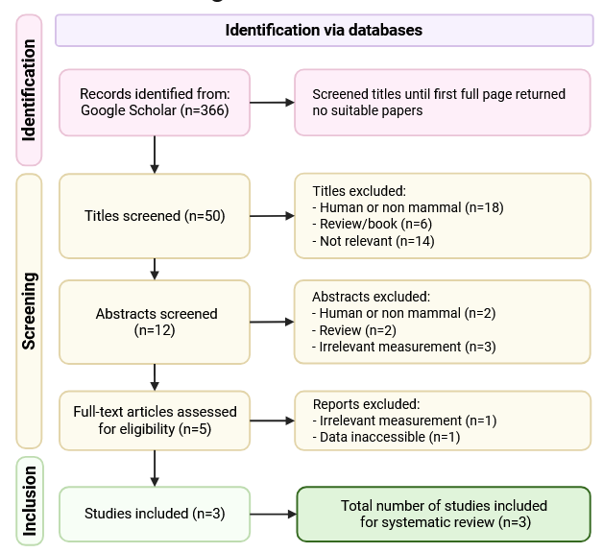
Figure 1. Flowchart according to PRISMA 2020 guidance showing the selection process from identification to inclusion through screening (Page et al., 2021; adapted from: Lopez, 2026).

Data cleaning and calculations
Following extraction by either download of excel sheets or conversion of PDF to excel, data was imported to R. Relative CC was calculated for one paper (Snell-Rood and Wick, 2013) as (braincase length x width x height)/body length, and for another as CC/skull length (Sluka et al., 2025). Relative (by skull length) CC was given in the final study (DePasquale et al., 2020).
Sluka designated ecoregions to each state from which samples were collected. As state specific sample size was insufficient for mean calculation in several locations, I followed their designation and assigned specimens from DePascal and Snell-Rood accordingly, where Minnesota was Plains and Pennsylvania was East.
Mean urban and mean rural relative CC with standard deviation was then calculated for each species by ecoregion, where not given by the original paper. I then used the effsize package to compute standardised difference in means corrected for small sample size using the Hedge’s g correction (Hedges, 1981; Torchiano, 2020).
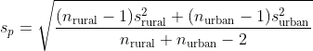
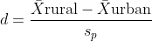
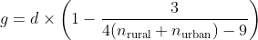

Modelling and analysis
Data were then

Results
Results
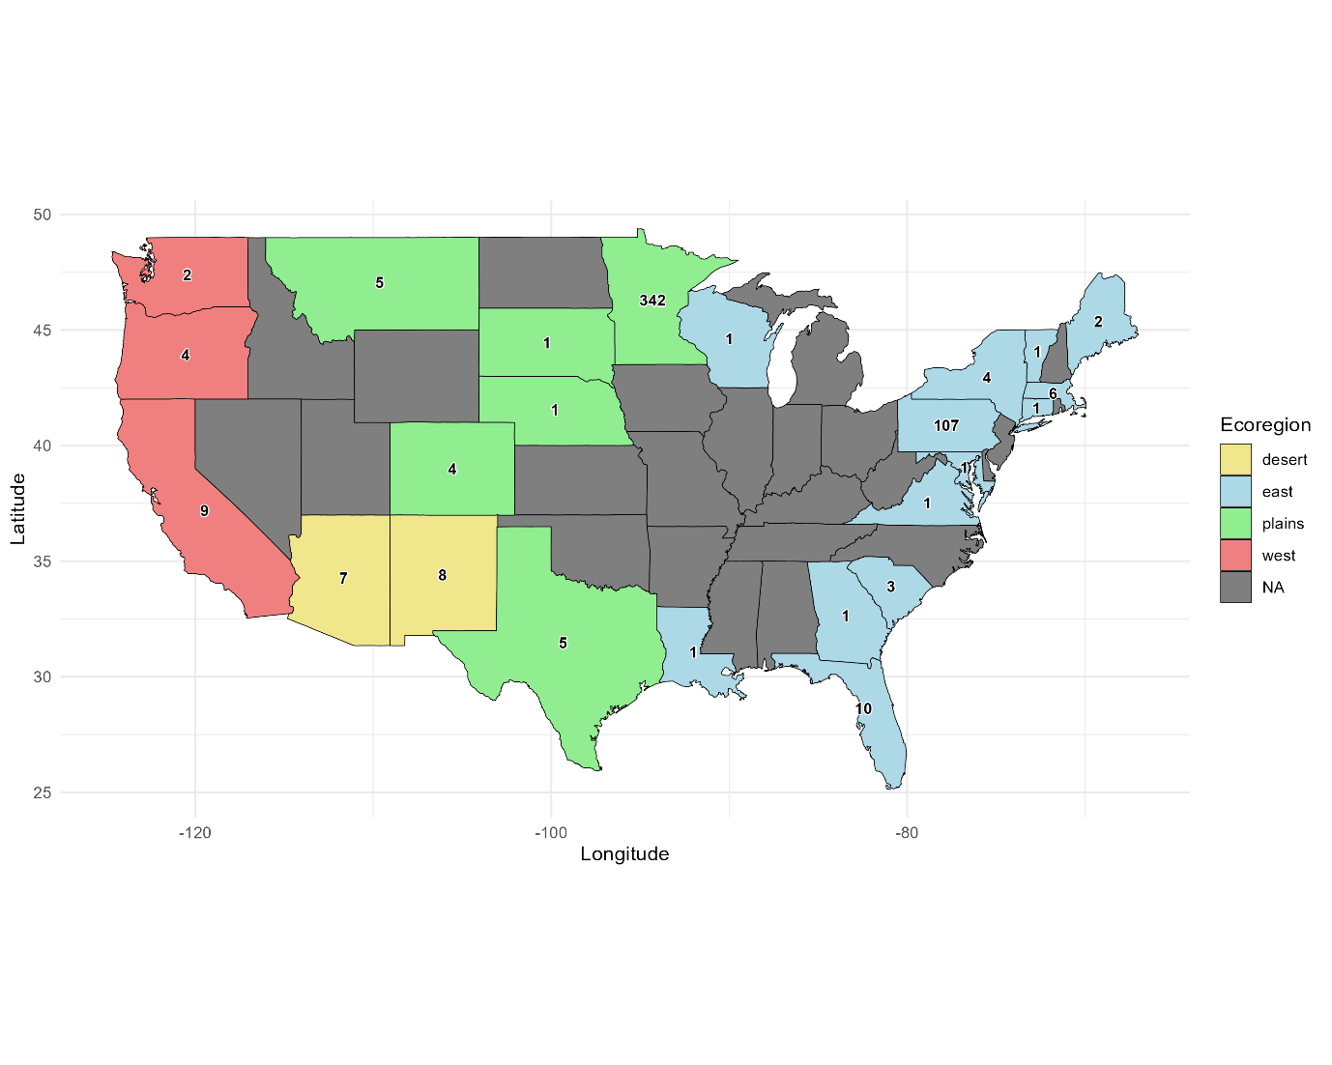
Figure X. Map of the United States of America indicating distribution of samples from across the studies by state. Colours indicate ecoregion, as designated by Sluka et al (2025). Base map from R package ‘maps’ (Becker et al., 2025).

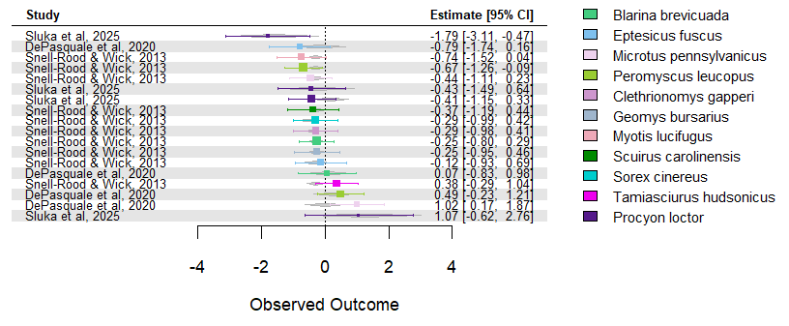
Figure X. Forrest plot showing effect size (Hedge’s g) and 95% confidence interval for each species separated by study. Bars indicate confidence intervals, box size indicates weighting of study and shading behind indicates (IDK WHAT).

Discussion
Discussion
Rural populations also under selection – nowhere truly wild in America and everything has been evolving for the exact same amount of time – without genetic comparison hard to say if selection

References
Becker, R.A. et al. (2025) ‘maps: Draw Geographical Maps’. Available at: https://cran.r-project.org/web/packages/maps/index.html (Accessed: 5 April 2026).
Benson-Amram, S. et al. (2016) ‘Brain size predicts problem-solving ability in mammalian carnivores’, Proceedings of the National Academy of Sciences, 113(9), pp. 2532–2537. Available at: https://doi.org/10.1073/pnas.1505913113.
Bishop, J.A. and Cook, L.M. (1975) ‘Moths, Melanism and Clean Air’, Scientific American, 232(1), pp. 90–99.
Campbell-Staton, S.C. et al. (2021) ‘Ivory poaching and the rapid evolution of tusklessness in African elephants’, Science, 374(6566), pp. 483–487. Available at: https://doi.org/10.1126/science.abe7389.
Cronin, A.D. et al. (2022) ‘A comprehensive overview of the effects of urbanisation on sexual selection and sexual traits’, Biological Reviews, 97(4), pp. 1325–1345. Available at: https://doi.org/10.1111/brv.12845.
DePasquale, C. et al. (2020) ‘Selection for increased cranial capacity in small mammals during a century of urbanization’, Journal of Mammalogy, 101(6), pp. 1706–1710. Available at: https://doi.org/10.1093/jmammal/gyaa121.
Dugatkin, L.A. (2020) ‘The Silver Fox Domestication Experiment’, Resonance, 25(7), pp. 987–1000. Available at: https://doi.org/10.1007/s12045-020-1014-y.
Freedman, A.H., Lohmueller, K.E. and Wayne, R.K. (2016) ‘Evolutionary History, Selective Sweeps, and Deleterious Variation in the Dog’, Annual Review of Ecology, Evolution, and Systematics, 47(Volume 47, 2016), pp. 73–96. Available at: https://doi.org/10.1146/annurev-ecolsys-121415-032155.
Hedges, L.V. (1981) ‘Distribution Theory for Glass’s Estimator of Effect Size and Related Estimators’, Journal of Educational Statistics, 6(2), pp. 107–128. Available at: https://doi.org/10.2307/1164588.
Johnson-Ulrich, L. and Forss, S. (2025) ‘How cognitively demanding is the urban niche? Reconsidering exaptation and habituation’, Animal Cognition, 28(1), p. 48. Available at: https://doi.org/10.1007/s10071-025-01965-y.
Leach, H.M. (2007) ‘Selection and the Unforeseen Consequences of Domestication’, Where the Wild Things Are Now: Domestication Reconsidered. Oxford, UK: Berg Publishers, pp. 71–95.
Lee, V.E. and Thornton, A. (2021) ‘Animal Cognition in an Urbanised World’, Frontiers in Ecology and Evolution, 9. Available at: https://doi.org/10.3389/fevo.2021.633947.
Lopez, R. (2026) PRISMA Flow Diagram for Systematic Reviews, BioRender. Available at: https://app.biorender.com/profile/template/details/t-6423014adab558c8916c750a-prisma-flow-diagram-for-systematic-reviews/?source=profile&username=rosalba_lopez&tab=templates (Accessed: 2 April 2026).
Lord, K.A. et al. (2020) ‘The History of Farm Foxes Undermines the Animal Domestication Syndrome’, Trends in Ecology & Evolution, 35(2), pp. 125–136. Available at: https://doi.org/10.1016/j.tree.2019.10.011.
Maune, A.L., Caspers, B.A. and Damas-Moreira, I. (2026) ‘The impact of urbanisation on social behaviour: a comprehensive review’, Biological Reviews, 101(2), pp. 1003–1035. Available at: https://doi.org/10.1002/brv.70113.
Page, M.J. et al. (2021) ‘The PRISMA 2020 statement: an updated guideline for reporting systematic reviews’, BMJ, 372, p. n71. Available at: https://doi.org/10.1136/bmj.n71.
Parsons, K.J. et al. (2020) ‘Skull morphology diverges between urban and rural populations of red foxes mirroring patterns of domestication and macroevolution’, Proceedings of the Royal Society B: Biological Sciences, 287(1928), p. 20200763. Available at: https://doi.org/10.1098/rspb.2020.0763.
Pierotti, R. and Fogg, B.R. (2018) ‘Review of The First Domestication: How Wolves and Humans Coevolved’, Ethnobiology Letters, 9(2), pp. 247–249.
Regacho, T. and delBarco-Trillo, J. (2021) ‘Morphological Stability of Rural Populations Confirms Their Use As Controls in Urban Ecology Studies’. Research Square. Available at: https://doi.org/10.21203/rs.3.rs-795506/v1.
Schreiber, M. et al. (2021) ‘Evolution and Domestication of Rye’, in M.T. Rabanus-Wallace and N. Stein (eds) The Rye Genome. Cham: Springer International Publishing, pp. 85–100. Available at: https://doi.org/10.1007/978-3-030-83383-1_6.
Sluka, C.M. et al. (2025) ‘Patterns of Raccoon Craniodental Morphology under Urbanization’, Integrative and Comparative Biology, 65(2), pp. 236–248. Available at: https://doi.org/10.1093/icb/icaf094.
Snell-Rood, E.C. and Wick, N. (2013) ‘Anthropogenic environments exert variable selection on cranial capacity in mammals’, Proceedings of the Royal Society B: Biological Sciences, 280(1769), p. 20131384. Available at: https://doi.org/10.1098/rspb.2013.1384.
Torchiano, M. (2020) ‘effsize: Efficient Effect Size Computation’. Available at: https://cran.r-project.org/web/packages/effsize/index.html (Accessed: 6 April 2026).
Wilkins, A.S., Wrangham, R.W. and Fitch, W.T. (2014) ‘The “Domestication Syndrome” in Mammals: A Unified Explanation Based on Neural Crest Cell Behavior and Genetics’, Genetics, 197(3), pp. 795–808. Available at: https://doi.org/10.1534/genetics.114.165423.

